# Term project „Static web site “

for *Technologies for web publishing I* (ATPW1) subject

**Student data**

|  |  |
| --- | --- |
| Name and surname: | Jose Luis Pedraza Román |
| Login (UHK intranet): | romanjo1 |
| Study branch: | Informatics |
| School year: | 2018/2019 spring term |

**Project summary**

|  |  |
| --- | --- |
| Project title: | Lawler’s Buffet of Pereira Aragüete |
| Annotation: | *I decided to do this project in relation to my stepfather’s law firm “Pereira Aragüete Abogados” in Spain because they didn’t have any web available and I think it’s a good way to start learning in order to continue developing it in the future. In addition, he has provided me with the necessary data to be able to complete the information on the web with greater realism, from the photographs to the personal information that appears on the web.*  *It consists of six webpages in which we can find different information about the company and its professionals, services, address, location and contact form, suitable to be seen on any device with screen width from 300px to 1400px thanks to its responsive design; a simplified version for printing is also available.* |

## The „Analysis and design“ part

## Project contractor

Who is the project contractor (real or fictitious) and what requirements he/she has?

|  |
| --- |
| *The project contractor is a real lawyer’s buffet of my stepfather.* |

## Target group

For what target groups (at least two) is the web site intended

|  |
| --- |
| *The website’s purpose is to inform people about the services we offer, let them know about our company and making them able to contact us.* |

## Information needs

What information will be contained on the site and what information needs (at least ten) will they cover

|  |
| --- |
| *You can find general and specific information about the specialization of professionals, our history, general information about our services and a contact form to ask us any questions. You can also find news about our most recent cases and a small photo gallery. A legal warning is included. Finally, we provide our full address, location and telephone number.* |

## Partition into pages

How will be the information needs partitioned into HTML pages of the site? The site should be composed of at least five pages

|  |
| --- |
| *Home-> General information about our specialization and location.*  *About us-> Brief history and specific information about the specialization of professionals.*  *Our services-> General information about our services.*  *Newspaper library-> You can also find news about our most recent cases and a small photo gallery.*  *Contact us-> Contact form to ask us any question.*  *Legal Warning-> CIF and registered office. Inform about the use of cookies on their website.* |

## Layout of the content

How will be the layout of the pages designed? Create wireframe models (using wireframe editor, or sketching by hand). For each page, give one wireframe model. If pages share one layout design, it is sufficient to give it once.

Create wireframe models for all size device variants used in your project.

Links to some wireframe editors:

* Enterprise Architect
* https://webdesign.tutsplus.com/articles/a-beginners-guide-to-wireframing--webdesign-7399
* http://mashable.com/2010/07/15/wireframing-tools/#cqEZrwR82Zq5
* <https://blog.capterra.com/free-and-open-source-wireframe-tools/>

🡪HOME:

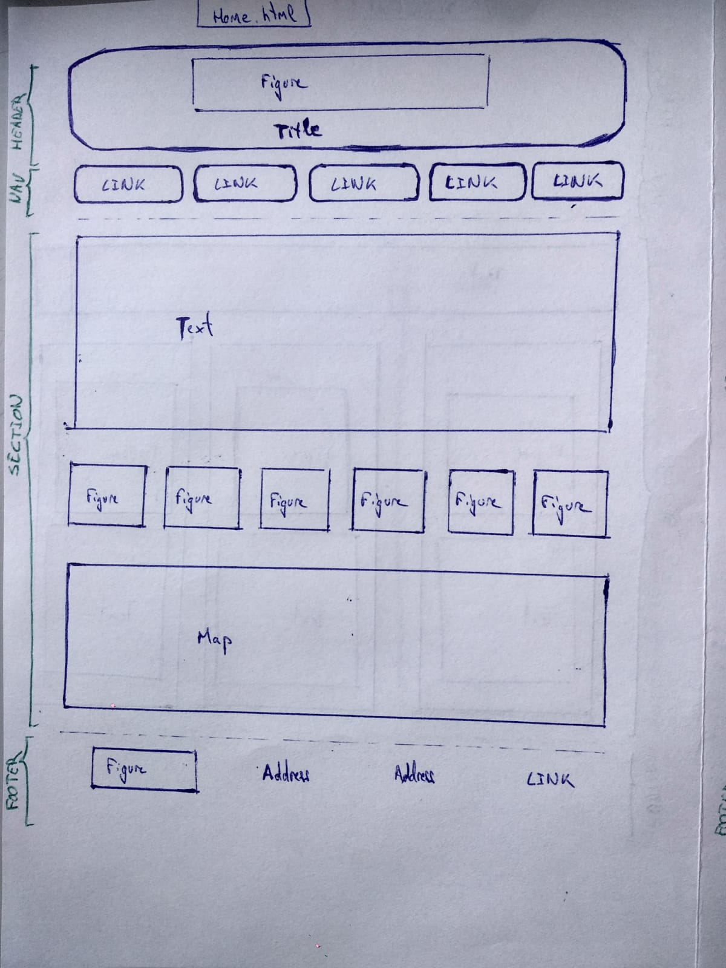

🡪About Us:

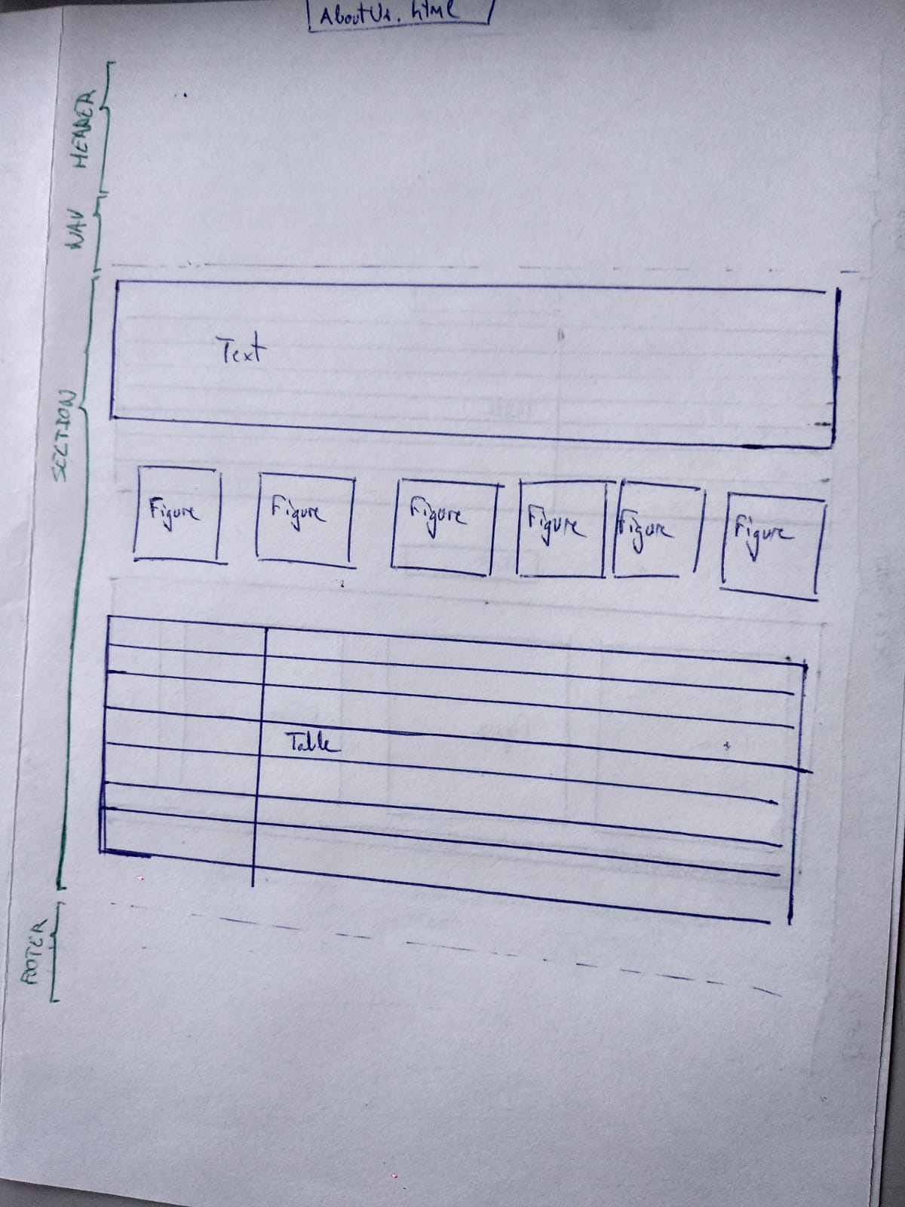

🡪Our Services:

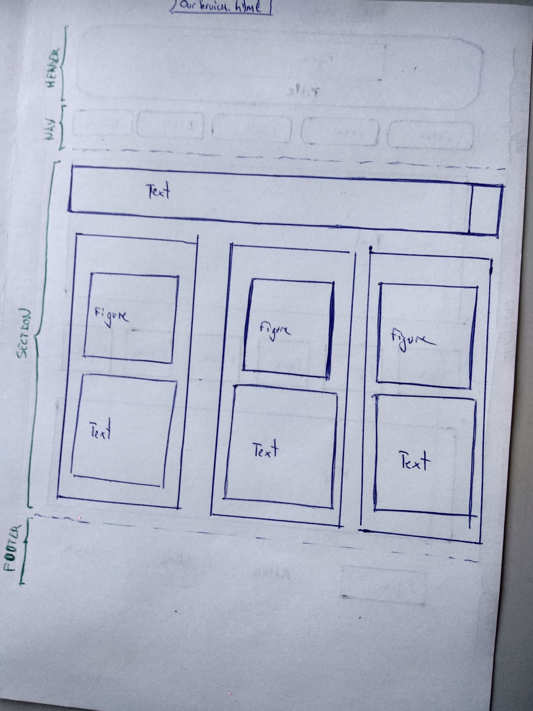

🡪Newspaper Library:

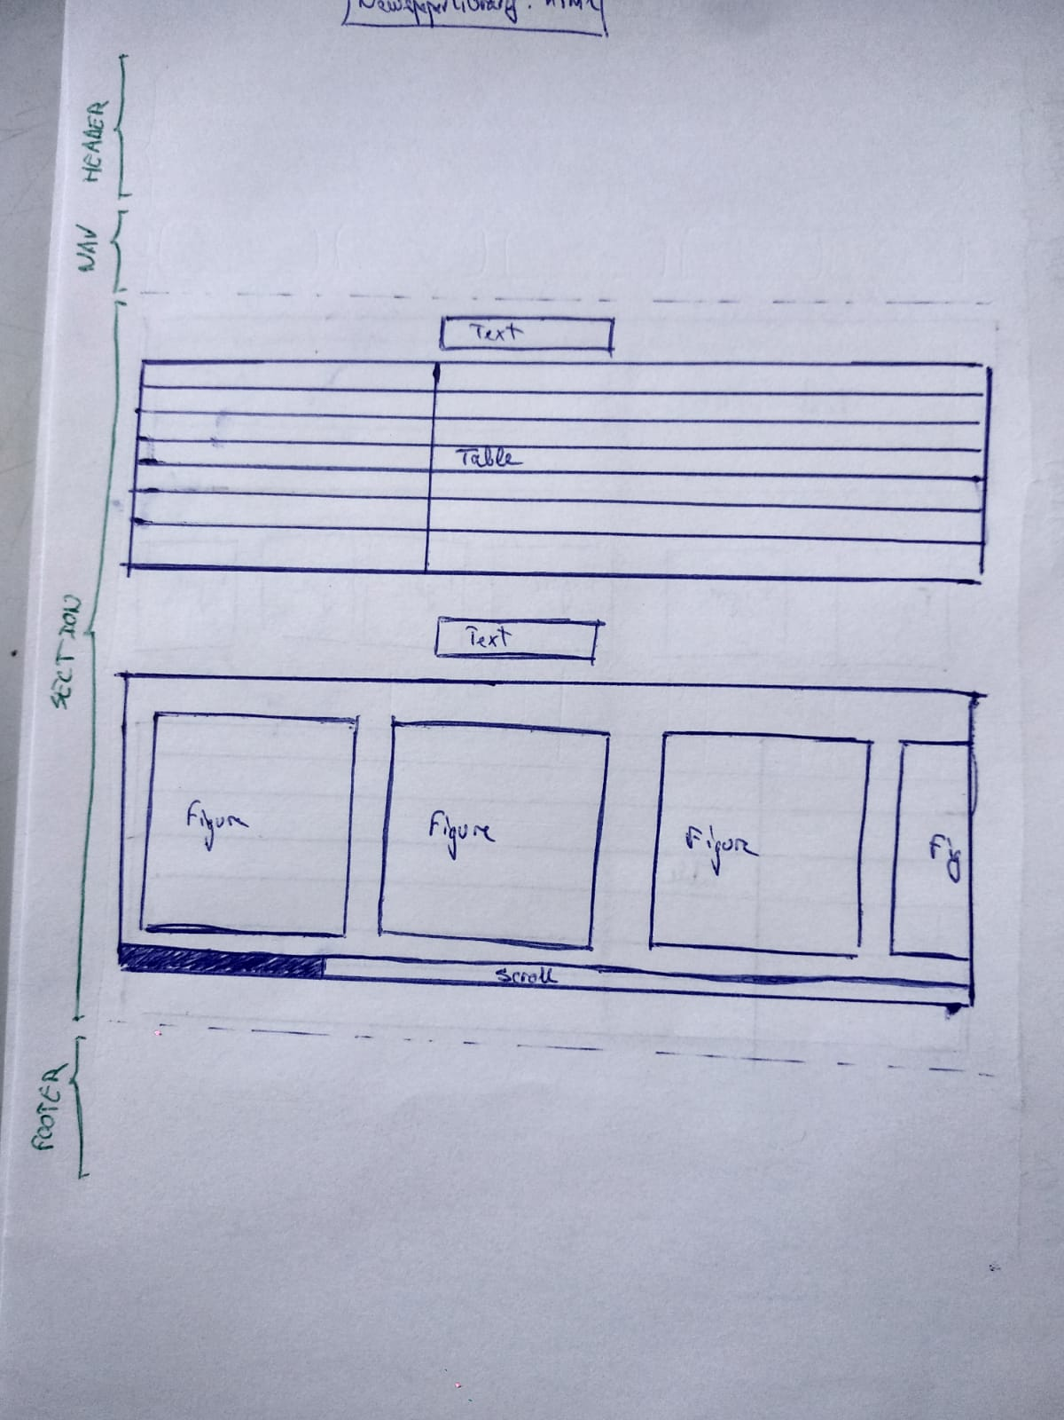

🡪Contact Us:

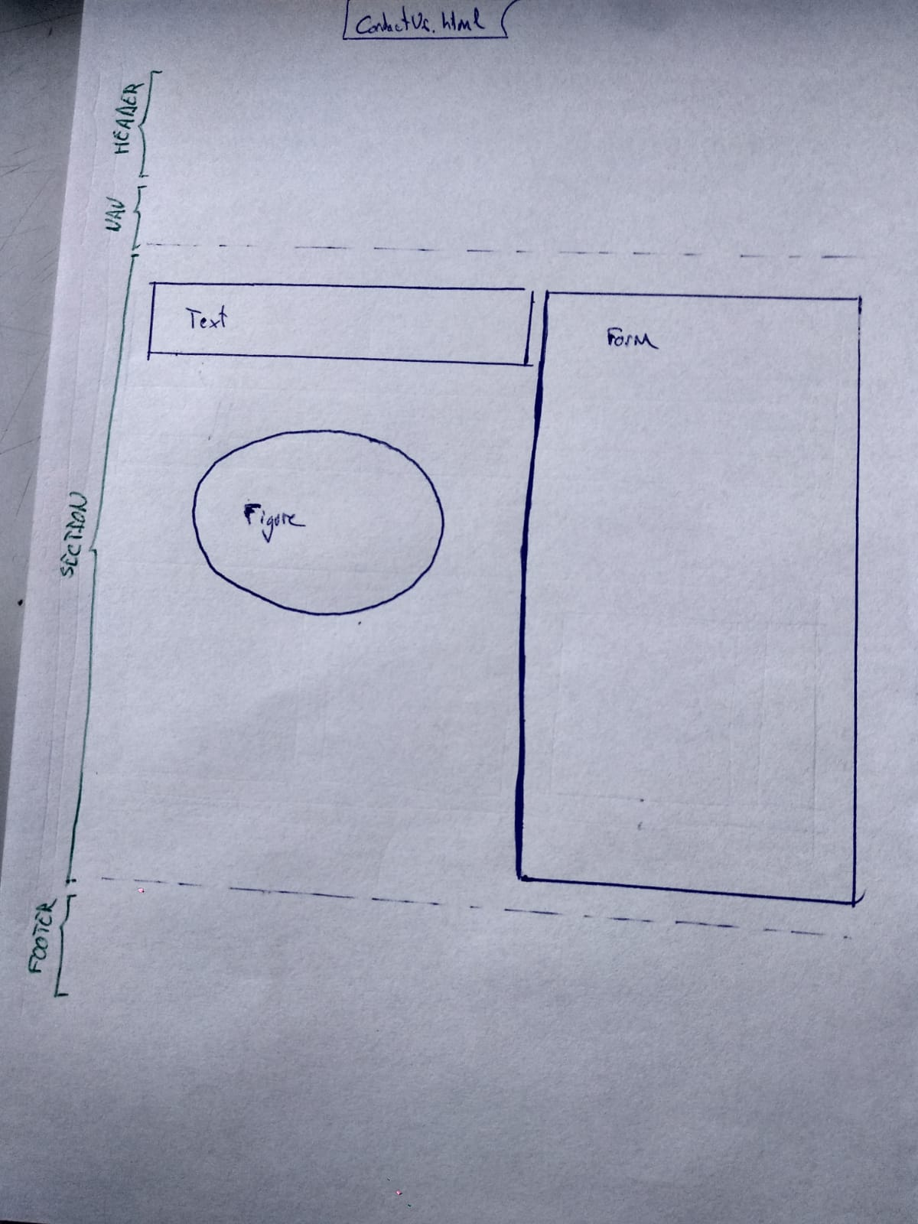

🡪Legal Warning:

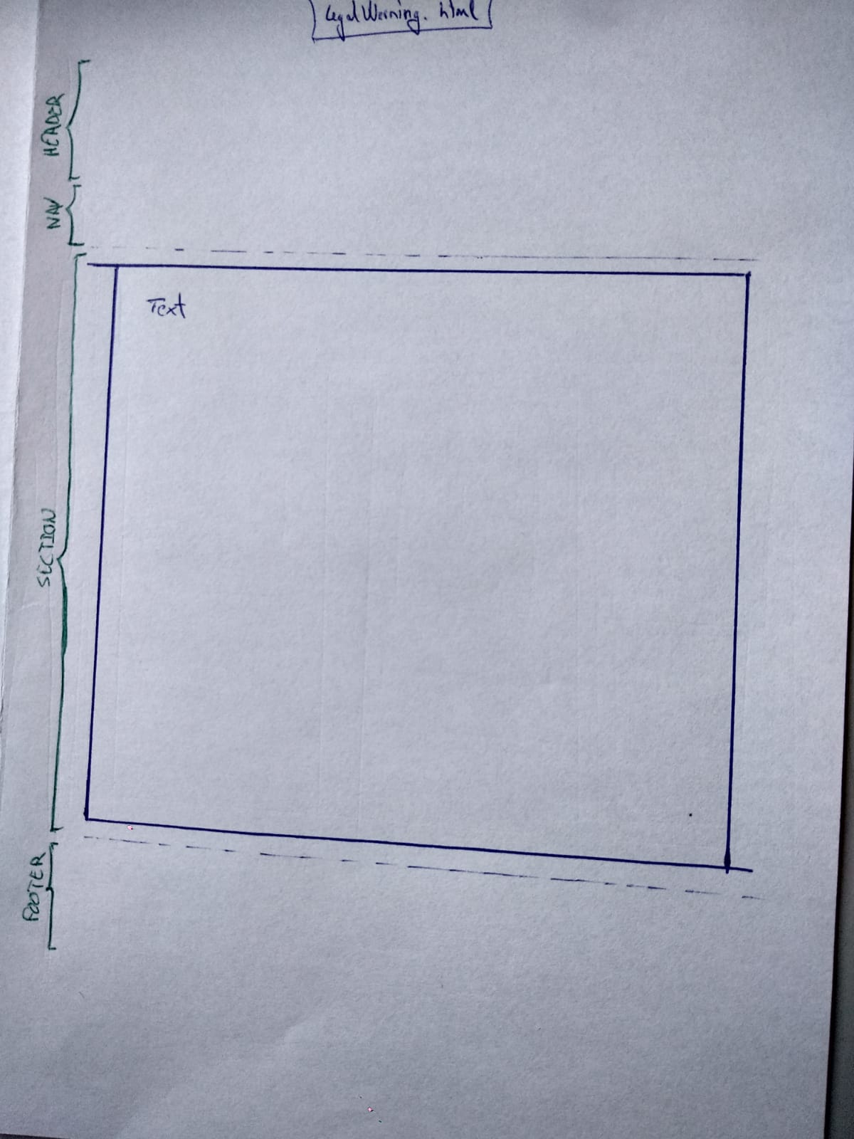

## Hypertext structure

What is the hypertext structure of the pages of the site, i.e. how will be the pages interconnected by hyperlinks? Give the hypertext structure using suitable editor (e.g. CmapTools https://cmap.ihmc.us/, VUE <http://vue.tufts.edu/>, any graphical editor) or draw it by hand. Give the hypertext link direction by an oriented link.

It is also possible to give the hypertext structure as a plain text. You can write “it is possible to get from every html page of the site to any of the rest of the pages of the site” and that’s it (well, if it is indeed true ☺)

It is possible to get from every html page of the site to any of the rest of the pages of the site.

## The „Implementation“ part

## URL of the project

Where the project is published.

http://lide.uhk.cz/fim/student/romanjo1/PROYECTO%20FINAL/Home.html

## Text content size (in number of words).

Give the number of all words of the text content of all the pages of the site.

1526 words

## Examples of application of the following elements in the project.

Give examples according to the requirements given bellow. Copy the HTML, CSS and/or JS code from the project.

## Structural semantic element (header, nav, aside, footer, section, article).

🡪HTML Home code:

<!doctype html>

<html>

<head>

</head>

<body>

<header>

<figure id="MainImg">

</figure>

</header>

<nav>

</nav>

<section class="sectHome">

<article>

</article>

<article>

</article>

<article>

</article>

</section>

<footer class="foothomebreak">

<figure>

</figure>

<address>

</address>

<address>

</address>

</footer>

</body>

</html>

🡪 HTML About Us code:

<!doctype html>

<html>

<head>

</head>

<body>

<header>

<figure id="MainImg">

</figure>

</header>

<nav>

</nav>

<section class="sectHome">

<article>

</article>

<article >

</article>

</section>

<footer>

<figure>

</figure>

<address>

</address>

<address>

</address>

</footer>

</body>

</html>

🡪 HTML Our Services code:

<!doctype html>

<html>

<head>

</head>

<body>

<header>

<figure id="MainImg">

</figure>

</header>

<nav>

</nav>

<article>

</article>

<footer>

<figure>

</figure>

<address>

</address>

<address>

</address>

</footer>

</body>

</html>

🡪 HTML Newspaper Library code:

<!doctype html>

<html>

<head>

</head>

<body>

<header>

<figure id="MainImg">

</figure>

</header>

<nav>

</nav>

<section id="sectLibrary" class="sectHome" >

<article class="libraryNews">

</article>

</section>

<footer>

<figure>

</figure>

<address>

</address>

<address>

</address>

</footer>

</body>

</html>

🡪 HTML Contact Us code:

<!doctype html>

<html>

<head>

</head>

<body>

<header>

<figure id="MainImg">

</figure>

</header>

<nav>

</nav>

<section id="sectServices">

</section>

<footer>

<figure>

</figure>

<address>

</address>

<address>

</address>

</footer>

</body>

</html>

🡪 HTML Legal Warning code:

<!doctype html>

<html>

<head>

</head>

<body>

<header>

<figure id="MainImg">

</figure>

</header>

<nav>

</nav>

<section id="sectServices">

<article>

</article>

</section>

<footer>

<figure>

</figure>

<address>

</address>

<address>

</address>

</footer>

</body>

</html>

## Implementation of the responsivity.

Style declaration for three different-size device variants and for print version.

🡪MEDIA 1

@media print{

body{

font-size: 85%;

}

header{

width: 96%;

height: 80%;

}

h1{

background-color: #999;

width: 100%;

font: normal 1.2em "Elegant","Pencil", Geneva, sans-serif;

color: #000;

text-decoration: overline;

padding-top: 1%;

padding-bottom: 1%;

font-style: italic;

text-align: center;

border-radius: 50% 50%;

}

#MainImg{

width: 80%;

height: 50%;

opacity: 1;

}

#MainImg img{

width: 90%;

height: 50%;

}

.lbar{display:none;}

#bar{display:none;}

#locationmap{display:none;}

.divS img{

float: left;

}

.divS figcaption{

font-size: 70%;

text-align: center;

}

.sectHome figure img{

padding:4%;

background:#666;

border-radius:25%;

-webkit-transition: none;

-o-transition: none;

-moz-transition: none;

-ms-transition: none;

box-shadow:#999 5px 5px 10px;

}

.sectHome figure img:hover{

display:none;

-webkit-transform: none;

-o-transform: none;

-moz-transform: none;

-ms-transform: none;

}

.divServices{

width: 100%;

margin: 0 auto;

display: flex;

flex-wrap: wrap;

justify-content: center;

flex-direction: row;

clear: both;

}

.figServ{

width: 100%;

hight: 80%;

margin: 2%;

border-radius:5%;

box-shadow:#999 5px 5px 15px;

padding: 4%;

background: none;

justify-content: center;

text-align: justify;

}

.imgServ{

border-radius: 20%;

border: 1px double #666;

margin: 2%;

float: left;

clear: both;

}

#galleryprint{display: none;}

.libraryGalery{display:none;}

#breaktableAbout{

page-break-before: always;

}

footer{

display: flex;

flex-wrap: wrap;

flex-direction: column;

justify-content: center;

}

.foothomebreak{

page-break-before: always;

}

}

🡪MEDIA 2

@media screen and (min-width: 1024px) and (max-width: 1400px) {

.lbar{

width: 30%;

word-wrap: normal;

margin: 0;

margin-bottom: 2%;

}

.contactText{

width:50%;

height: 100%;

float: left;

margin: 3%;

}

#contactImg{

width: 80%;

margin-top: 8%;

margin-left: 1%;

}

.contactForm{

display: flex;

justify-content: center;

align-items: center;

margin-left: 10%;

margin-top: 4%;

}

}

🡪MEDIA 3

@media screen and (min-width: 480px) and (max-width: 768px) {

header{

width: 97%;

}

.lbar{

width: 30%;

margin: 0 auto;

margin-bottom: 2%;

}

.divServices{

width: 100%;

margin: 0 auto;

display: flex;

flex-wrap: wrap;

justify-content: center;

flex-direction: row;

clear: both;

}

.figServ{

width: 100%;

hight: 100%;

margin: 2%;

border-radius:5%;

box-shadow:#999 5px 5px 15px;

padding: 5% ;

background: -webkit-linear-gradient(right, #33F 1%, #36F 3%, #39F 70%, #3CF 100%);

background: -o-linear-gradient(right, #33F 1%, #36F 3%, #39F 70%, #3CF 100%);

background: -moz-linear-gradient(right, #33F 1%, #36F 3%, #39F 70%, #3CF 100%);

background: -ms-linear-gradient(right, #33F 1%, #36F 3%, #39F 70%, #3CF 100%);

justify-content: center;

text-align: justify;

}

.imgServ{

border-radius: 20%;

border: 1px double #666;

margin: 2%;

float: left;

clear: both;

}

.contactText{

width:100%;

height: 100%;

float: left;

margin: 2%;

}

#contactImg{

width: 60%;

height: 100%;

border-radius: 50%;

box-shadow:#666 60px 20px 40px;

margin-top: 1%;

margin-left: 0 auto;

}

.contactForm{

width: 100%;

display: flex;

justify-content: center;

}

.divS{

display: flex;

justify-content: space-around;

flex-wrap: wrap;

}

footer{

display: flex;

flex-wrap: wrap;

flex-direction: column;

justify-content: center;

}

}

MEDIA 4

@media screen and (min-width: 768px) and (max-width: 1024px){

.lbar{

width: 100%;

margin: 0;

margin-bottom: 2%;

word-wrap: normal;

}

.divServices{

width: 100%;

margin: 0 auto;

display: flex;

flex-wrap: wrap;

justify-content: center;

flex-direction: row;

clear: both;

}

.figServ{

width: 100%;

hight: 100%;

margin: 2%;

border-radius:5%;

box-shadow:#999 5px 5px 15px;

padding: 5% ;

background: -webkit-linear-gradient(right, #33F 1%, #36F 3%, #39F 70%, #3CF 100%);

background: -o-linear-gradient(right, #33F 1%, #36F 3%, #39F 70%, #3CF 100%);

background: -moz-linear-gradient(right, #33F 1%, #36F 3%, #39F 70%, #3CF 100%);

background: -ms-linear-gradient(right, #33F 1%, #36F 3%, #39F 70%, #3CF 100%);

justify-content: center;

text-align: justify;

}

.imgServ{

border-radius: 20%;

border: 1px double #666;

margin: 2%;

float: left;

clear: both;

}

.contactText{

width:50%;

height: 100%;

float: left;

margin: 3%;

}

#contactImg{

width: 80%;

margin-top: 25%;

margin-left: 1%;

}

.contactForm{

display: flex;

justify-content: center;

align-items: center;

margin-left: 10%;

margin-top: 4%;

}

footer{

display: flex;

flex-wrap: wrap;

flex-direction: column;

justify-content: center;

}

}

## Inclusion of multimedia content.

Integration of video, audio into HTML5 code.

<iframe src="https://www.google.com/maps/embed?pb=!1m18!1m12!1m3!1d3106.270794858551!2d-6.979010149365044!3d38.87204585594342!2m3!1f0!2f0!3f0!3m2!1i1024!2i768!4f13.1!3m3!1m2!1s0xd16e42522677367%3A0xa0e407acfacb82dd!2sAv.+Villanueva%2C+3%2C+06005+Badajoz%2C+Espa%C3%B1a!5e0!3m2!1ses!2scz!4v1554379787530!5m2!1ses!2scz" width="600" height="450" frameborder="0" style="border:0" allowfullscreen></iframe>

## Usage of JavaScript elements.

Complementary interactive functionality.

## Checklist

This protocol of the term project has to contain the following items:

* Contractor
* Target groups
* Information needs
* Site partition into pages
* Content layout design
* Hypertext structure
* Project public location (URL)
* Text content size (in number of words)
* Structural semantic elements used
* Description of responsivity implementation
* Multimedia content reference
* Usage of JavaScript elements for interactive functionality